http://images.clipartpanda.com/stop-sign-clipart-z7TaM5XiA.pnghttp://www.havepartywilltravel.com/wp-content/uploads/2014/09/map-marker-small-hi.pnghttp://www.havepartywilltravel.com/wp-content/uploads/2014/09/map-marker-small-hi.png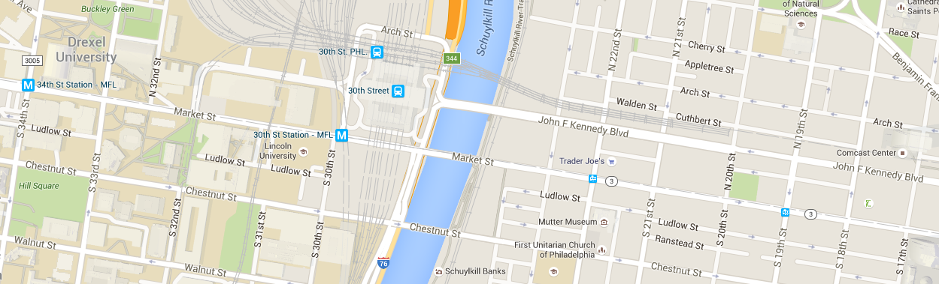

Please Select the Bus Route…